**IS2545 - DELIVERABLE 3: Web Testing with BDD**

**Black-Box Tests for Ruby Compilation Visualizer**

Name: Xin Wen

ID: xiw91

Github: https://github.com/Seloen/Test1111

**Summary**

The issue I encountered when I was writing this test was finding user stories, since I was not sure how to category them. At first I tried to write user stories like “when I try to input a=1 b=2 c=a+b puts c, then I should get it compiled successfully.” Then I found it was difficult to create scenarios. So I changed the stories to like “when I try to tokenize the input”.

Another issue was that I did not know how to deal with the newline issue.

Below are my first version

String myText ="str1='Hello world'\nputs str1";

myText = myText.replace("\n", Keys.chord(Keys.SHIFT, Keys.ENTER));

I tried to replace \n with the action of pressing the “ENTER” key. But it turned out that there is no need to do that. The input in the first line is enough.

When testing parsing, I tried to input a wrong input: “putsc”. The space is missing in this test. What I want to get is that “put” cannot be showed on the received page since the system would treat “putsc” as a variable. However, I failed this assertion test of assertionFalse(t.contains(“puts”)). I think the reason is that puts literally extracted from variable “putsc”.

All tests from user story 3 for compilation are failed since according to the requirement in the compiling phase, any program that contains “puts” should have the “putstring” operation showed. However, “putstring” operation is not on the received page. (I commented the assertion of existence of “putstring” to get the test worked properly.)

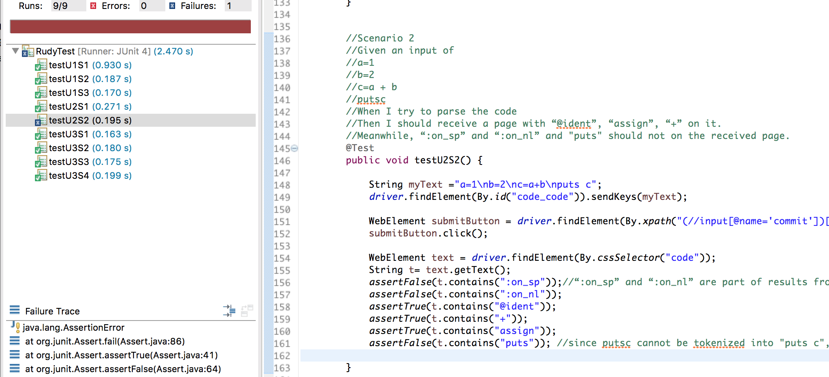

**User Stories**

1. *As a user*

*I want to tokenize the code I wrote*

*So that code can then be parsed.*

Scenario 1

Given an input of

str1="Hello world"

puts str1

When I try to tokenize the code

Then I should receive a page with “:on_sp”, “:on_ident”, “:on_nl”, “:on_op” on it.

Scenario 2

Given an input of

puts “abc”

When I try to tokenize the code

Then I should receive a page with “:on_sp”, “:on_ident” on it, and “:on_nl”, “:on_op” not on it.

Scenario 3

Given an input of

a=1

b=2

c=a+b

puts c

When I try to tokenize the code

Then I should receive a page with “:on_sp”, “:on_ident”, “:on_nl”, “:on_op” on it.

1. *As a user*

*I want to parse the code I wrote*

*So that I can see the AST of my code in order to get it compiled.*

Scenario 1

Given an input of

a=1

b=2

c=a+b

puts c

When I try to parse the code

Then I should receive a page with “@ident”, “assign”, “+”, “puts” on it. Meanwhile, “:on_sp” and “:on_nl” should not on the received page.

Scenario 2

Given an input of

a=1

b=2

c=a + b

putsc

When I try to parse the code

Then I should receive a page with “@ident”, “assign”, “+” on it. Meanwhile, “:on_sp” and “:on_nl” and “puts” should not on the received page.

1. *As a user*

*I want to compile the code I wrote*

*So that AST can be compiled into lower level byte code.*

Scenario 1

Given an input of

a=1

b=2

c=a+b

puts c

When I try to parse the code

Then I should receive a page with “putstring”, “opt_plus”, “putobject” on it.

Scenario 2

Given an input of

a=1

b=2

c=a-b

puts c

When I try to parse the code

Then I should receive a page with “putstring”, “opt_minus”, “putobject” on it.

Scenario 3

Given an input of

a=1

b=2

c=a*b

puts c

When I try to parse the code

Then I should receive a page with “putstring”, “opt_mult”, “putobject” on it.

Scenario 4

Given an input of

a=1

b=2

c=a / b

puts c

When I try to parse the code

Then I should receive a page with “putstring”, “opt_div”, “putobject” on it.